# Amos Mobile User Manual V3.0

Author: Kevin Saegerman

Release date: 21/04/2015

**INDEX**

Amos Mobile User Manual V3.0 1

1 Functionalities 2

2 Initializing The Device 2

2.1 Starting the App 2

2.2 Defining the Server 3

2.3 Initial Synchronization 5

3 General Use 7

3.1 Virtual Keyboard 7

3.2 Check Buttons 8

3.3 Synchronization 8

3.4 Enable Pistol Grip Trigger 8

4 Inventory 9

4.1 Standard Procedure 9

4.2 Progress Information 10

4.3 Process the Registered Stock Corrections 11

5 Check Deliveries 12

6 Expert Modus 13

6.1 Spare Parts 13

6.2 Locations 14

7 Custom Labels 16

8 Setup Connection with Mobile Printer 18

8.1 WINDOWS MOBILE 6.1 18

8.2 WINDOWS MOBILE 6.5 19

8.3 Printer Settings 23

# Functionalities

The Amos Mobile application has been developed for Windows Mobile devices (version 6.1 and 6.5). The application will make use of a light version of the Amos database.

Following functionalities can be handled:

* Perform an inventory check
* Check deliveries
* Link stock items to a location
* Move stock items between locations
* Create stock transactions
* Print stock item labels
* Print user defined labels

The application will be able to synchronize the performed actions to the Amos database.

# Initializing The Device

**Following steps only need to executed once.**

## Starting the App

|  |  |
| --- | --- |
| After installing the app and booting the device (press red button on top for 5 seconds), the login screen of the application will be loaded.  The first login will have to happen with user “hit”, password “liam”, because the device does not contain any Amos data yet.  When you log in, the app will warn you that a synchronization will be needed before you can access all functionalities. |  |
| You will notice that several menu items in the main menu will be disabled, because of you’ll need to execute the synchronization first. |  |

## Defining the Server

The first step before you can synchronize is to define the server on which the main Amos database is running.  
Go to Settings-->Sync Server. Fill in the name of the server and press “Update”.

|  |  |
| --- | --- |
|  |  |

|  |  |
| --- | --- |
| You will receive following message. Press “Yes”.    You will be asked to confirm by typing “update” (case insensitive). Press “OK”. |  |

The server is defined now and you will be able to synchronize the device.

## Initial Synchronization

|  |  |
| --- | --- |
| After defining the server, you’ll have to execute the first synchronization to download the Amos data on the device.  Put the device in a cradle, connected to one of the client pc’s on the network.  Verify on the pc if the connection with the mobile device is active. On Windows XP you will need **ActiveSync**, on Windows 7 you’ll need to start **Windows Mobile Device Center**.  In the Main Menu, go to menu item “Synchronize”. Press the “Synchronize” button. | cid:image001.png@01D07CD8.B48C0600 |

|  |  |
| --- | --- |
| **Windows XP:** connect with ActiveSync  G:\1. Team\Logistics\Amos\Amos Mobile 3.0\activesync.png | **Windows 7:** connect with Amos Mobile Device Center |

|  |  |
| --- | --- |
| The synchronization process will start. The first synchronization will take some time because a lot of data have to be downloaded.  cid:image002.png@01D07CD8.B48C0600 | When the synchronization process is finished, the app will automatically return to the previous screen.  The status of the process and the last synchronization date will be updated.  cid:image003.png@01D07CD8.DAE89480 |

|  |  |
| --- | --- |
| If the process fails, first check the cradle and the connection with the pc. More information can be found in de log file which will be accessible by the “View Sync Log” button. | cid:image001.png@01D07CDA.CE1CC0D0 |

After the synchronization, all menu items will be enabled.  
**You can now log off and log in again with your own Amos user account.**

**Issue: The first time you login can take several minutes!**

|  |  |
| --- | --- |
| http://www.wpclipart.com/signs_symbol/assorted/assorted_6/exclamation_sign.png | * Be aware that you can repeat this action, but that all data on the mobile device will be erased. * It is a requirement to do this action when the mobile device has been moved between different Amos installations. |

# General Use

## Virtual Keyboard

|  |  |
| --- | --- |
| When focussing an input field, you will be able to open/close a virtual keyboard.  This is more easy to use than the physical keyboard of the device. |  |

## Check Buttons

The “Check” buttons on the screens can be used to validate a manually entered ID. This can be useful if the barcode label is unreadable.

Location and part ID can be found below the barcode.

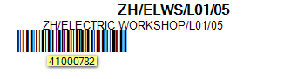

## Synchronization

In order to work with up-to-date information and to send the changes done on the mobile device to the Amos dabase it is necessary to synchronize.

If the dataset on the mobile device is older than 2 days, you will be obliged to synchronize before you can take further actions.

Look at the steps described in chapter 2.3 to start the synchronization process.

## Enable Pistol Grip Trigger

Press Start --> Settings --> System --> Trigger Settings

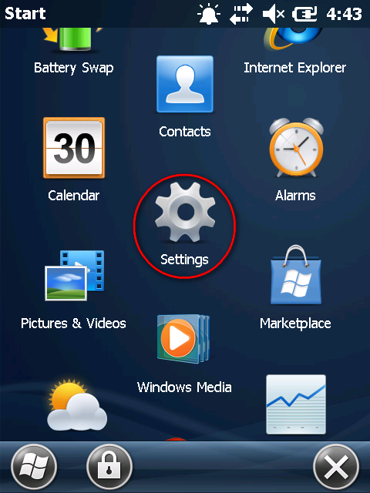 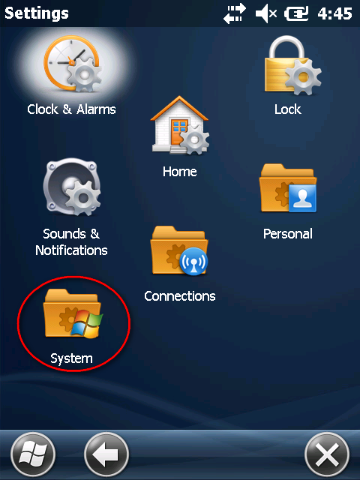

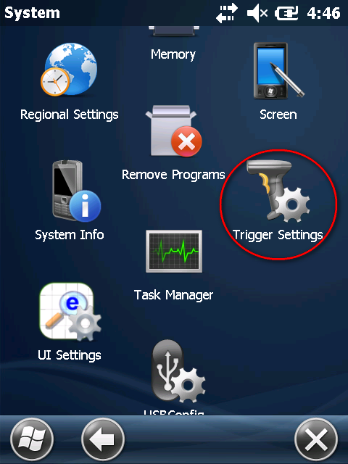 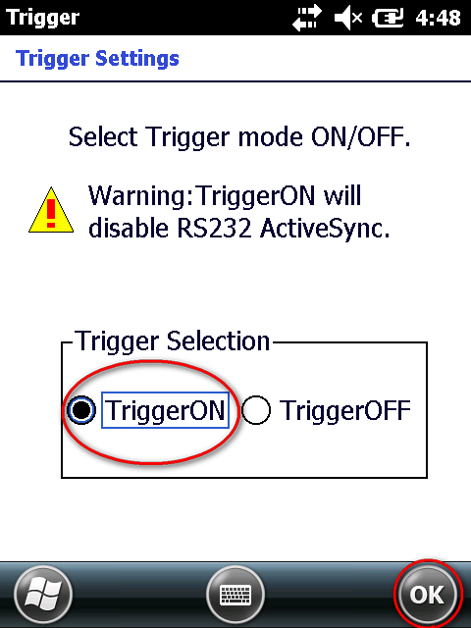

# Inventory

## Standard Procedure

Before starting an inventory check it is appropriate to perform a synchronization, to download the latest stock amounts.

|  |  |
| --- | --- |
| The main process of an inventory check is:   1. Scan a location 2. Scan a part 3. Enter the counted amount   Repeat step 2 and 3 for all parts on the location.  If you would like to begin the inventory check for another locations, press the “Change Location” button and start over again. |  |

|  |  |
| --- | --- |
| http://www.wpclipart.com/signs_symbol/assorted/assorted_6/exclamation_sign.png  When scanning a part which is not yet registered on this location, you will get a warning but you will be able to enter an amount. This will result in a new stock location in Amos after the approval. |  |

## Progress Information

When scanning a location, you will get information about how many parts are located on it.  
We make a distinction between parts with stock and without stock, because parts without stock will probably not be found anymore.

It gives an indication about the amount of parts you’ll have to check.

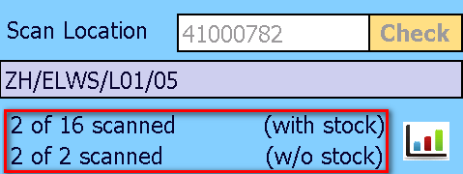

|  |  |
| --- | --- |
| This button will give an overview of the amount of scanned locations/parts during your scanning session.  Scanning session = the period between 2 synchronizations |  |

## Process the Registered Stock Corrections

When you have finished the inventory check, you will have to synchronize with the Amos database.

Synchronizing will **not** result in an automatic update of the stock.

This has to be done with the Amos XT Utility “Inventory Check”.

|  |  |
| --- | --- |
| http://www.wpclipart.com/signs_symbol/assorted/assorted_6/exclamation_sign.png | Be aware that after synchronizing you’re scanning session will be ended and the registered inventory checks will be cleared from the mobile device. |

# Check Deliveries

|  |  |
| --- | --- |
| With the “Check Deliveries” tool you will be able to scan the yellow package labels.  When you scan a package, the information about the order form, part and expected amount will be displayed.  You can overwrite the received amount if less or more units have been sent.  You will also be able to print part labels simultaneously by toggle on the “Print Label” checkbox. The amount of labels can also be defined.  If a package has already been scanned, you will notice the status “Checked” (in green).  If a package is already received, you will still be able to print a label by pressing the “Enter” button, but it will not cause a double receiving.  http://www.wpclipart.com/signs_symbol/assorted/assorted_6/exclamation_sign.png  After synchronizing, the received amounts will be visible in the **Amos XT Transport module**, where you can receive the packages (which will result in receiving the order forms and modifying the stock). |  |

# Expert Modus

The expert modus will only be available for specific user groups because the actions will directly influence the Amos database after synchronization. This functionality was also available in the previous version of Amos Mobile.

## Spare Parts

|  |  |
| --- | --- |
| When scanning a part label, you will get the list of all locations where the part is located according to Amos.  With the “Make Default” button you will be able to change the default location of the part.  With the “Move Stock” button you will be able to move the selected stock to another location. |  |
| When moving stock, you will be able to scan the target location.  By default the amount is set to the total amount of the source location, but you can reduce the amount to perform a partial move.  If you want to move the total stock you can automatically delete the source location by toggle on the “Delete source location” checkbox at the bottom of the screen.  By pressing the “Confirm” button the stock will be moved and you will return to the previous screen. |  |

## Locations

|  |  |
| --- | --- |
| When scanning a location label, you will get a list of all spare parts located on in, with their stock.  You will be able to print a part label by selecting a part and press the “Print Label” button. |  |

|  |  |
| --- | --- |
| You will be able to execute a stock transaction:   * Select the part * Choose the type of transaction * Define the amount * Press the “Change stock” button   If the stock of a part is 0, you will be able to remove that part from the location, by pressing the “Remove Part” button.  If you want to add a part to the location, you can press the “Add Part” button. |  |

|  |  |
| --- | --- |
| When you want to add a part on a location, you’ll have different options.  By default, the “Set as default location” checkbox will be toggled on.  Scanning a part label will simply register this part to the location and will set the location as default. |  |

|  |  |
| --- | --- |
| When the “Enter Stock” checkbox is toggled on, you will have to enter the amount of stock and press the “Confirm” button to accept the change. |  |

|  |  |
| --- | --- |
| When using the “Overwrite Modus”, all existing stock locations of the scanned part will be removed and the total stock will be moved to the new location.  This functionality is mostly used for new build vessels when all the parts have to be given a new location.  The user will get always a specific warning when he wants to use the Overwrite Modus.    When you go back to the previous screen you will immediatly see all performed actions in the list. |  |

# Custom Labels

|  |  |
| --- | --- |
| Custom labels can printed with the mobile printer.  You can enter a text and set the margins and size parameters.  These values can be saved by defining a name and pressing the “Save” button. |  |

|  |  |
| --- | --- |
| With the “Load” button you will get an overview of all defined custom labels and select one to reload the settings.  You are also able to delete a saved custom label.  http://www.wpclipart.com/signs_symbol/assorted/assorted_6/exclamation_sign.png  Saved custom labels are stored on the mobile device and will not be available on other mobile devices. |  |

# Setup Connection with Mobile Printer

## WINDOWS MOBILE 6.1

Go to Start 🡪 Program Files 🡪 BTExplorer Choose New Connection

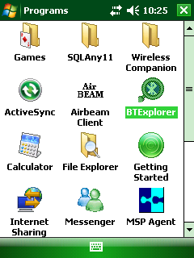 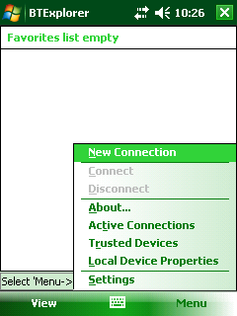

Select “Connect to Printer”, Next Select Zebra P4T (Serial Number is displayed), Next

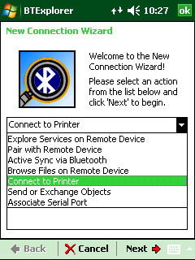 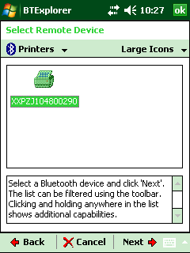

Fill in favorite name, Next

(if more than one zebra printer is used) Make Connection

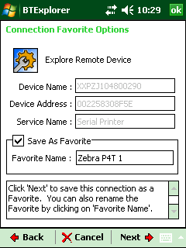 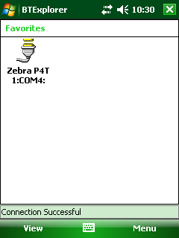

## WINDOWS MOBILE 6.5

The order of the screens can differ.

Go to Start🡪Settings Connections

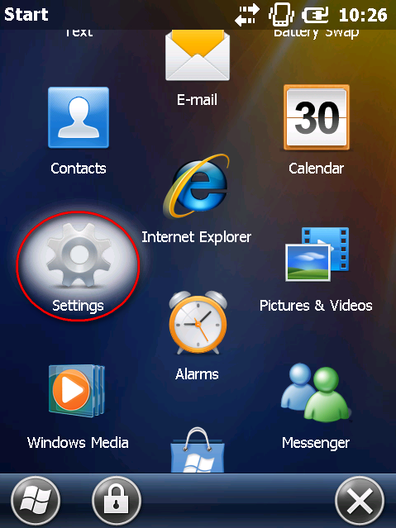 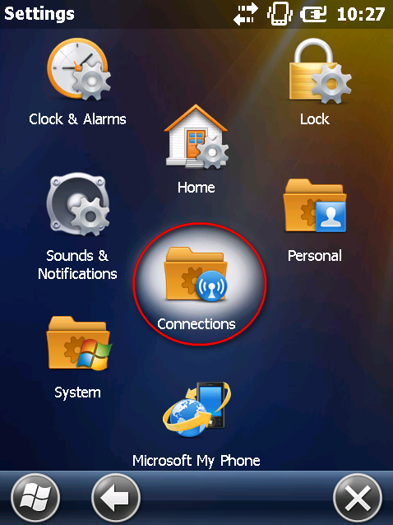

Bluetooth

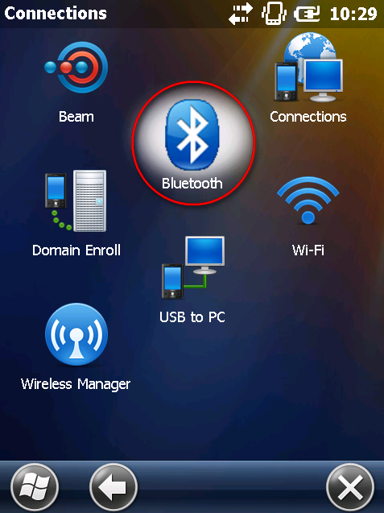 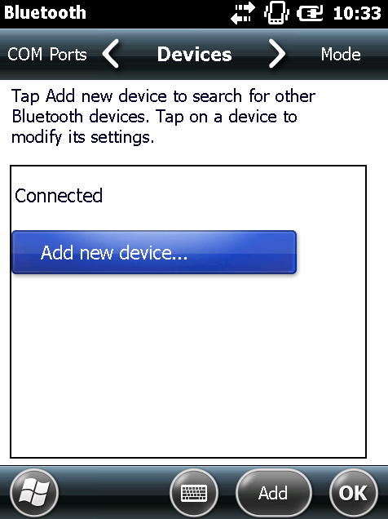

Select Printer Device and press Next Leave the passcode empty, press Next

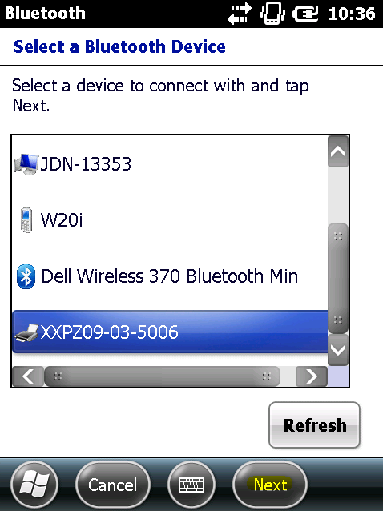 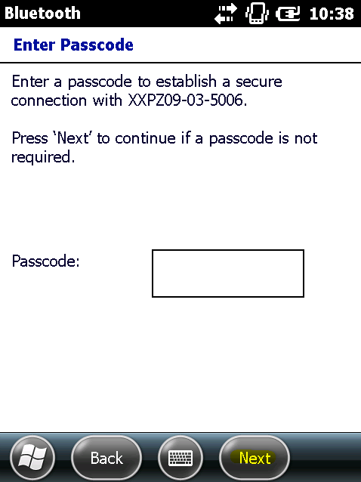

Press Yes Press Advanced

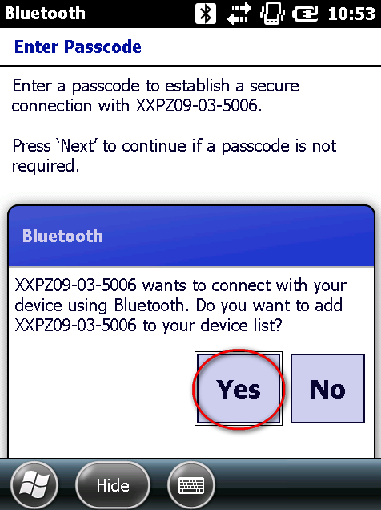 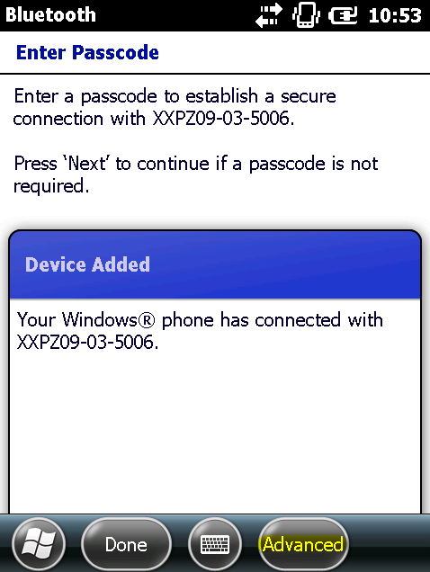

**Can take some minutes!**

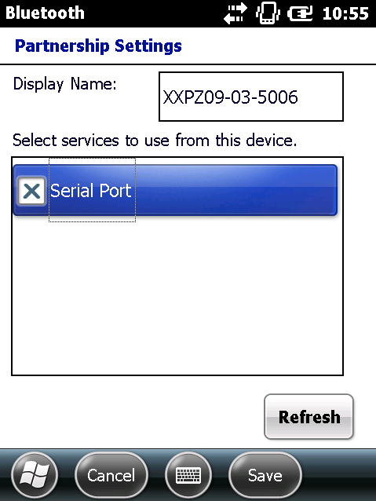 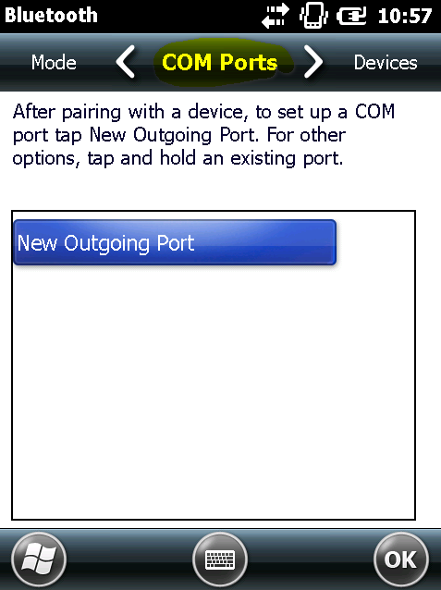

Press Next Select a free com port. Sometimes a port can be in use and you will need to select another one.

Toggle off “Secure Connection”, press Finish

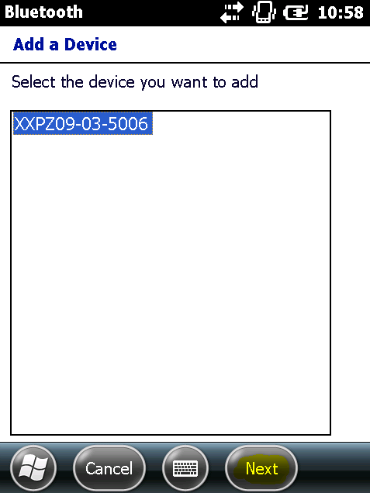 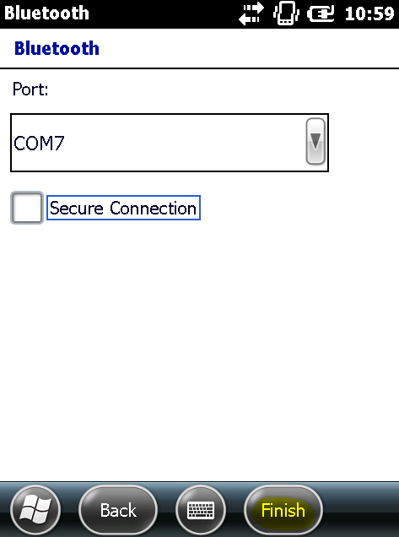

Leave passcode empty, press Cancel

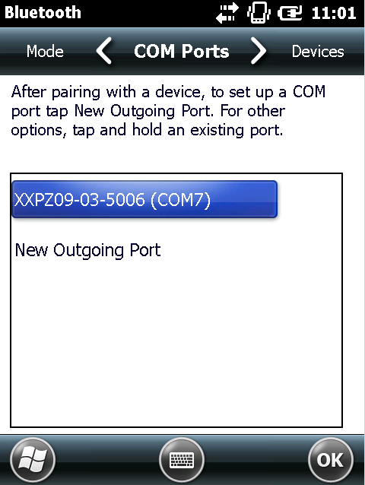 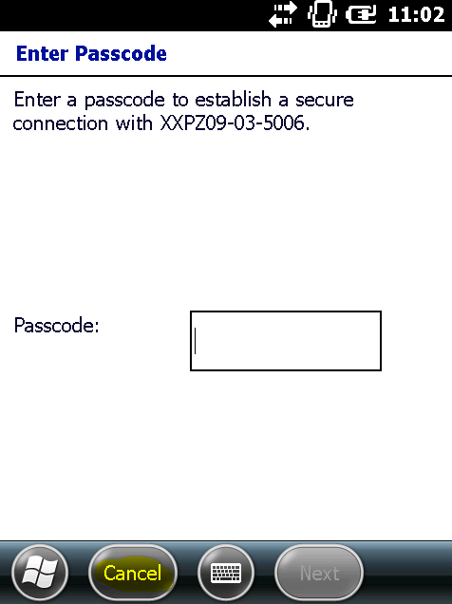

In Amos Mobile you can calibrate the printer in the printer settings menu.

## Printer Settings

In the Amos Mobile App go to menu Settings --> Printer Settings

|  |  |
| --- | --- |
| There are 3 menu items | Connection Settings: Technical parameters to connect the mobile label printer |

You can **test the printer connection** to check if the printer is configured correctly.

You can **calibrate the connected printer** when a new cartridge or label roll has been installed.